OPERATION FALSE ASSURANCE

Team Name | BYEBUST
Phase Number / Title | Phase 2 / OFA P2-08: Information-Stealer Endpoint
Incident Date | 2025-10-03
Date Submitted | 2026-08-22

REPORT SCORING
No. | Category | Percentage | Points
1 | Executive Summary | 10% | 100
2 | Incident Timeline & Attack Reconstruction | 15% | 150
3 | Victim & Infrastructure Identification | 10% | 100
4 | Technical Investigation, Evidence & Attack Analysis | 55% | 550
5 | Containment, Eradication & Recovery Recommendations | 5% | 50
6 | Report Quality & Professional Presentation | 5% | 50
 | TOTAL | 100% | 1,000
Evidence Requirement: Major findings must be supported by Security Onion, Kibana, Elasticsearch, Zeek, Suricata, or other authorized evidence. Unsupported findings may receive no more than 50% of the available points for that finding.

1. EXECUTIVE SUMMARY
10% - 100 Points
Summarize the activity observed during this phase. State what happened, the affected system, the nature of the malicious activity, and the operational significance.
On 2025-10-03, host 10.8.20.101 (internal/victim segment) was observed sending repeated HTTP POST requests to external IP 79.141.165.202:80, resolving to the URI path /a9b024dccb2b4f24.php.
Suricata (ET Open ruleset) fired high-severity alerts "ET MALWARE StealC CnC Activity (POST)" (sid 2066559) and "ET MALWARE StealC_V2 CnC Activity (POST)" (sid 2066280), both categorized as Malware Command-and-Control Activity, with rule metadata explicitly tagging malware_family: Stealc.
Zeek http.log corroborates the alert: POST /a9b024dccb2b4f24.php HTTP/1.1, Content-Type: application/json, Host: 79.141.165.202, returning HTTP 200 OK - consistent with a StealC information-stealer beaconing to its command-and-control / drop panel and exfiltrating harvested credential/browser data.
79.141.165.202 is hosted by HZ Hosting Ltd (AS59711) in Amsterdam, Netherlands - a bulletproof/VPS provider commonly abused for stealer C2 infrastructure.
Operational significance: this confirms an active information-stealer infection on 10.8.20.101 with successful outbound exfiltration to attacker infrastructure; the endpoint should be treated as compromised.

2. INCIDENT TIMELINE AND ATTACK RECONSTRUCTION
15% - 150 Points
Record the significant events in chronological order. Use UTC for all timestamps.
Date / Time (UTC) | Source | Destination | Protocol / Port | Activity / Observation

Attack Reconstruction
Describe how the activity developed during the phase, what the attacker accomplished, and how the available evidence supports the conclusion.
18:02:45 - 18:02:47 (+08:00) / 10:02:45 - 10:02:47 UTC: Suricata detects three back-to-back CnC POST check-ins from 10.8.20.101 to 79.141.165.202:80 (sids 2066559, 2066280 x2), indicating the StealC loader had already executed on the host and begun its check-in cycle.
18:04:09 - 18:04:12 (+08:00) / 10:04:09 - 10:04:12 UTC: Zeek records the associated HTTP transaction - POST /a9b024dccb2b4f24.php with a 160-byte JSON request body and an 84-byte 200 OK response, matching the classic StealC "send stolen data / receive config" exchange.
Across the observation window, 72 total events (zeek.http, zeek.file, suricata.alert) were logged between 10.8.20.101 and 79.141.165.202, showing a sustained, repeated beaconing pattern rather than a single one-off connection.
No further stages (secondary payload download, lateral movement) were observed to this specific destination within the reviewed data; activity is limited to stealer check-in / exfiltration POSTs.
Conclusion: the timeline supports an active StealC infostealer C2 channel, with the attacker infrastructure functioning as the drop/gate endpoint for exfiltrated data.

3. VICTIM AND INFRASTRUCTURE IDENTIFICATION
10% - 100 Points

Affected System
IP Address | 10.8.20.101
Hostname | Not Determined
User Account | Not Determined
Operating System | Not Determined
Active Directory Domain | Not Determined
System Role | Workstation / client segment (10.8.20.0/24)
Status | Confirmed Compromised - active StealC info-stealer C2 traffic observed
Status: Confirmed Compromised / Suspected Compromised / Targeted / Scanned / Not Determined

Relevant Infrastructure
Type | Domain / IP Address | Port | Purpose / Observation
C2 / Exfiltration Endpoint | 79.141.165.202 | 80/TCP | StealC CnC panel / drop - receives POST /a9b024dccb2b4f24.php (HZ Hosting Ltd, AS59711, Amsterdam, NL)
Victim Host | 10.8.20.101 | 63958/63963 (ephemeral) | Infected endpoint originating the StealC CnC POST requests

4. TECHNICAL INVESTIGATION, EVIDENCE AND ATTACK ANALYSIS
55% - 550 Points
This section contains the main technical findings. Each significant conclusion should be supported by evidence.

4.1 Analyst Findings
No. | Finding / Objective | Answer / Result | Evidence Ref.
1 | Information-stealer destination IP address | 79.141.165.202 | Figure 1-3
2 | Information-stealer PHP URI path | /a9b024dccb2b4f24.php | Figure 2, 4
3 | Malware family identified | StealC / StealC_V2 | Figure 1, 2
4 | Suricata signature IDs | 2066559 (StealC CnC Activity POST), 2066280 (StealC_V2 CnC Activity POST) | Figure 1
5 | Victim host | 10.8.20.101 | Figure 3, 5
6 | Destination port / protocol | 80/TCP, HTTP | Figure 3, 5
7 | HTTP method / response | POST, HTTP/1.1 200 OK | Figure 2, 4
8 | C2 infrastructure ownership | HZ Hosting Ltd, AS59711, Amsterdam, Netherlands | Figure 5
9 | Total related events observed | 72 events (suricata.alert / zeek.http / zeek.file) between 10.8.20.101 and 79.141.165.202 | Figure 3
10 | CTF Answer | CTK{79.141.165.202|/a9b024dccb2b4f24.php} | Figure 1-5

4.2 Malware / Tool Identification
Malware / Tool / Technique | Evidence | Confidence
StealC (Suricata: ET MALWARE StealC CnC Activity (POST), sid 2066559) | Suricata rule metadata malware_family: Stealc; POST /a9b024dccb2b4f24.php to 79.141.165.202 | High
StealC_V2 (Suricata: ET MALWARE StealC_V2 CnC Activity (POST), sid 2066280) | 3x high-severity alerts, same source/destination pair and time window | High
Technical analysis:
StealC is a commodity information-stealer (MaaS) that harvests browser-stored credentials, cookies, autofill data, cryptocurrency wallet files, and system information, then exfiltrates it via an HTTP POST to a PHP gate script on its C2 panel.
The observed traffic pattern - repeated POST requests with small JSON bodies to a randomly-named PHP file (/a9b024dccb2b4f24.php) hosted on a bare IP address - is consistent with published StealC C2 behavior and is directly reflected in the Emerging Threats signature metadata (malware_family: Stealc).
No sample file was recovered from the PCAP/import set for hashing; malware identification is based on network-behavioral indicators (Suricata signature match + Zeek http.log) rather than static analysis.

4.3 Network Activity
Time (UTC) | Source IP | Destination IP | Port | Protocol | Domain / Host | Observation
2025-10-03 10:02:45 UTC | 10.8.20.101 | 79.141.165.202 | 80 | TCP/HTTP | 79.141.165.202 | ET MALWARE StealC CnC Activity (POST) - sid 2066559
2025-10-03 10:02:45 UTC | 10.8.20.101 | 79.141.165.202 | 80 | TCP/HTTP | 79.141.165.202 | ET MALWARE StealC_V2 CnC Activity (POST) - sid 2066280
2025-10-03 10:02:46 UTC | 10.8.20.101 | 79.141.165.202 | 80 | TCP/HTTP | 79.141.165.202 | ET MALWARE StealC_V2 CnC Activity (POST) - sid 2066280
2025-10-03 10:04:12 UTC | 10.8.20.101 | 79.141.165.202 | 80 | TCP/HTTP | 79.141.165.202 | Zeek http.log: POST /a9b024dccb2b4f24.php -> 200 OK
Analysis:
All observed traffic to 79.141.165.202 is plaintext HTTP on TCP/80. No DNS resolution step was required / captured, as the malware connects directly to the hardcoded IP address (Host header = 79.141.165.202).
72 correlated events (suricata.alert, zeek.http, zeek.file) were returned when pivoting on destination.ip:"79.141.165.202", confirming this is a sustained, repeated beacon rather than an isolated hit.
community_id 1:9l1BjSVXGaDlnEJ+WCYS0zcOplY= ties the Suricata alert and Zeek http/file records to the same underlying TCP flow (uid CihR3v3KQtjvDZLiI4).

4.4 Command-and-Control Activity
C2 Domain / IP | Port | Protocol | First Seen | Observation
79.141.165.202 | 80 | HTTP | 2025-10-03 10:02:45 UTC | StealC/StealC_V2 CnC check-in and data-exfil POST to /a9b024dccb2b4f24.php
Assessment:
The C2 channel uses HTTP POST with a JSON content-type to a single, hardcoded IP:port (79.141.165.202:80) and a fixed, obfuscated-looking PHP URI (/a9b024dccb2b4f24.php), which functions as the StealC gate script.
The server responded HTTP/1.1 200 OK to each POST, indicating the C2 panel actively accepted and acknowledged the beacon/exfiltrated data rather than the connection being blocked or refused.

4.5 Files and Payloads
Filename | Source / URL | Type | Observation
Not Determined | N/A | N/A | No executable/dropper file was recovered from the import set for this destination; only the resulting HTTP CnC/exfil POST traffic was captured.
Use “Not Determined” when the exact filename or content cannot be confirmed from the available evidence.

4.6 Credential Collection / Exfiltration
Collection Method | StealC info-stealer harvesting (browser credentials/cookies/autofill, per malware family behavior)
Information Collected | Likely browser-stored credentials, cookies, autofill data, and system/host information (based on StealC's known capability; specific field-level content not recoverable from metadata alone)
Exfiltration Method | HTTP POST (application/json body, 160 bytes) to external C2
Destination | 79.141.165.202
Protocol / Port | 80/TCP (HTTP)
Assessment:
The 160-byte JSON POST body observed in Zeek http.log (request_body_len=160) is consistent with a compact stealer check-in/exfil payload rather than a large bulk file transfer.
The exact plaintext contents of the POST body were not recoverable from the available metadata/log fields; this is noted as an evidence limitation (Section 7).

4.7 Lateral Movement
Time (UTC) | Source | Destination | Port / Protocol | Activity
State whether the destination was merely contacted, targeted, or confirmed compromised.
No lateral movement traffic (SMB, RDP, WMI, etc.) associated with 79.141.165.202 or 10.8.20.101 was identified in this dataset; 79.141.165.202 was only contacted as an external C2/exfiltration endpoint.
Status: Contacted (external C2 endpoint) - not applicable to internal lateral movement.

4.8 Ransomware Activity
Ransomware Family
Initial Source | Not Determined
First Target | Not Determined
Propagation Protocol | Not Determined
Destination Port | Not Determined
Exploit / Technique | Not Determined
Additional Propagation Sources | Not Determined
Affected Systems | Not Determined
First Observed Time | Not Determined
Last Observed Time | Not Determined
Assessment:
No ransomware indicators (file encryption, ransom notes, mass file-rename activity) were observed in connection with this finding.

4.9 Indicators of Compromise
Indicator | Type | Purpose / Assessment | Recommended Action
79.141.165.202 | IPv4 / C2 destination | StealC CnC and exfiltration endpoint | Block outbound at firewall/proxy; add to threat-intel blocklist
/a9b024dccb2b4f24.php | HTTP URI (PHP gate) | StealC exfil/check-in script path on C2 host | Alert on POST requests matching this URI pattern
StealC / StealC_V2 | Malware family | Suricata sid 2066559 / 2066280 match | Ensure ET Open/Pro ruleset is enabled and updated
10.8.20.101 | Internal host | Source of CnC beacons - suspected infected endpoint | Isolate host, run EDR/AV scan, force credential reset

4.10 Investigation Evidence
Query / Filter Used:
rule.name:*StealC* (Alerts) | destination.ip:"79.141.165.202" (Hunt)
Finding:
Confirmed StealC/StealC_V2 CnC POST traffic from 10.8.20.101 to 79.141.165.202 (URI /a9b024dccb2b4f24.php), 4 Suricata alerts + 72 correlated Zeek events.
________________________________________________________________________________
Evidence Reference: Figure 1-5
Kibana / Elasticsearch
Alerts / Suricata
Time (UTC) | Alert | Source | Destination | Remarks
Zeek Logs Used
- conn
- dns
- http
- ssl / tls
- smtp
- files
- dhcp
- kerberos
- smb
- other: __________________
Relevant observation:
http log records (zeek.http) and Suricata alerts share network.community_id 1:9l1BjSVXGaDlnEJ+WCYS0zcOplY=, confirming both are the same underlying flow.
________________________________________________________________________________

4.11 Evidence Register
Evidence No. | Description | Source
E-01 | Alerts list: ET MALWARE StealC / StealC_V2 CnC Activity (POST), 4 high-severity events, dest 79.141.165.202:80 | Security Onion
E-02 | N/A - Kibana not used directly; Security Onion Alerts/Hunt UI (Elasticsearch-backed) used instead | Kibana
E-03 | Raw alert payload showing POST /a9b024dccb2b4f24.php, Host: 79.141.165.202, rule metadata malware_family: Stealc | Suricata
E-04 | Zeek http.log expanded record: http.method POST, http.uri /a9b024dccb2b4f24.php, destination.ip 79.141.165.202, GeoIP Amsterdam/NL | Zeek
E-05 | Hunt pivot query destination.ip:"79.141.165.202" returning 72 correlated events | Other
Each screenshot should include a short caption explaining what it shows.

4.12 MITRE ATT&CK Mapping
Tactic | Technique | Technique ID | Evidence
Command and Control (TA0011) | Application Layer Protocol: Web Protocols | T1071.001 | Suricata rule metadata (mitre_tactic_id TA0011, mitre_technique_id T1071); HTTP POST C2 to 79.141.165.202
Exfiltration (TA0010) | Exfiltration Over C2 Channel | T1041 | 160-byte JSON POST body sent to /a9b024dccb2b4f24.php over the same C2 HTTP channel
Credential Access (TA0006) | Credentials from Password Stores (browser) | T1555.003 | StealC malware-family behavior (credential/browser data theft); not directly observable in metadata
Collection (TA0009) | Data from Local System | T1005 | Consistent with StealC's local data-harvesting prior to exfiltration

5. CONTAINMENT, ERADICATION AND RECOVERY
5% - 50 Points
Provide recommendations based on the findings from this phase.

Immediate Actions
1. Block outbound traffic to 79.141.165.202 (and the /a9b024dccb2b4f24.php URI pattern) at the perimeter firewall/proxy.
2. Isolate host 10.8.20.101 from the network and run a full EDR/AV scan to locate and remove the StealC loader.
3. Force a reset of all credentials that may have been stored in browsers on 10.8.20.101 (accounts, saved passwords, cookies/session tokens).

Additional Recommendations
Network:
Add 79.141.165.202 to firewall/proxy/threat-intel blocklists; deploy/verify the ET Open StealC signatures (sid 2066559, 2066280) are enabled and alerting.
Endpoint:
Run EDR sweep across the 10.8.20.0/24 segment for the same IOC (destination IP / URI pattern / StealC signatures) to identify any additional infected hosts.
Accounts / Credentials:
Reset passwords and invalidate active sessions for any accounts used on 10.8.20.101, prioritizing browser-saved and cached credentials.
Active Directory, if applicable:
Not Determined - no AD-specific indicators observed in this finding.
Recovery:
Reimage/rebuild 10.8.20.101 if StealC persistence is confirmed; monitor for renewed beacons to 79.141.165.202 post-remediation.

6. CONCLUSION
Provide the team’s final assessment of the phase. State what happened, what system was affected, what the attacker accomplished, the evidence supporting the conclusion, the impact, and how this phase relates to the larger incident.
Investigation of Security Onion Alerts and Hunt data confirms that host 10.8.20.101 was compromised by the StealC / StealC_V2 information-stealer and actively communicated with its command-and-control / exfiltration endpoint at 79.141.165.202 on TCP/80.
The malware issued repeated HTTP POST requests to /a9b024dccb2b4f24.php, matching the ET Open signatures "StealC CnC Activity (POST)" (sid 2066559) and "StealC_V2 CnC Activity (POST)" (sid 2066280), and the server responded 200 OK, confirming successful check-in / data exfiltration.
This conclusion is supported directly by Suricata alert metadata (malware_family: Stealc), the raw HTTP request payload, and corroborating Zeek http.log records sharing the same network.community_id.
Impact: confirmed loss of confidentiality for any credentials/browser data present on 10.8.20.101 at the time of infection.
This finding represents the information-stealer / exfiltration stage of the broader Operation False Assurance intrusion and should be correlated with the remote-access findings from earlier in Phase 2.

7. EVIDENCE LIMITATIONS
List any information that could not be confirmed from the available data. Do not present assumptions as confirmed facts.
The exact plaintext contents of the 160-byte POST body (i.e., the specific stolen data fields) could not be recovered from the available metadata/log fields.
No malware sample (dropper/loader binary) was recovered from the import set for hashing or static analysis; identification relies on network-behavioral indicators (Suricata signature + Zeek http.log).
The victim host's hostname, OS, and user account could not be determined from the available network metadata alone.
Not Determined: whether this was the initial or a subsequent StealC check-in for this host (only the reviewed time window was analyzed).

8. APPENDICES

Appendix A - Investigation Queries
Query: rule.name:*StealC* (Security Onion Alerts, Last 365 days)
Query: destination.ip:"79.141.165.202" (Security Onion Hunt, Last 365 days)
Query: event.dataset:zeek.http AND destination.ip:"79.141.165.202" (drill-down for http.uri / http.method)

Appendix B - Figures and Screenshots
Use sequential figure numbers. Each figure should include a short caption describing what the evidence demonstrates.
Figure | Caption / Description
Figure 1 | Figure 1 - Security Onion Alerts: ET MALWARE StealC CnC Activity (POST) / StealC_V2 CnC Activity (POST), 4 high-severity events, source 10.8.20.101 -> destination 79.141.165.202:80.
Figure 2 | Figure 2 - Expanded Suricata alert raw payload showing 'POST /a9b024dccb2b4f24.php HTTP/1.1', Host: 79.141.165.202, and rule metadata malware_family: Stealc.
Figure 3 | Figure 3 - Security Onion Hunt pivot on destination.ip:"79.141.165.202" returning 72 correlated events (suricata.alert / zeek.http / zeek.file).
Figure 4 | Figure 4 - Zeek http.log expanded record showing http.method: POST and http.uri: /a9b024dccb2b4f24.php.
Figure 5 | Figure 5 - Zeek http.log expanded record showing destination.ip: 79.141.165.202, destination.port: 80, GeoIP Amsterdam, Netherlands (HZ Hosting Ltd, AS59711).
Figure 6

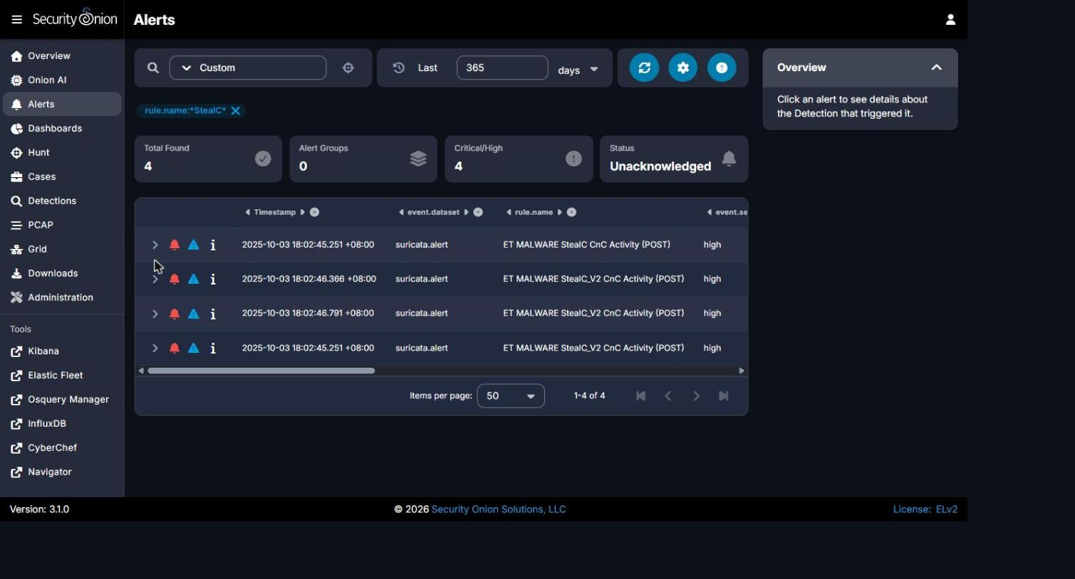
Figure 1 - Security Onion Alerts: ET MALWARE StealC CnC Activity (POST) / StealC_V2 CnC Activity (POST), 4 high-severity events, source 10.8.20.101 -> destination 79.141.165.202:80.

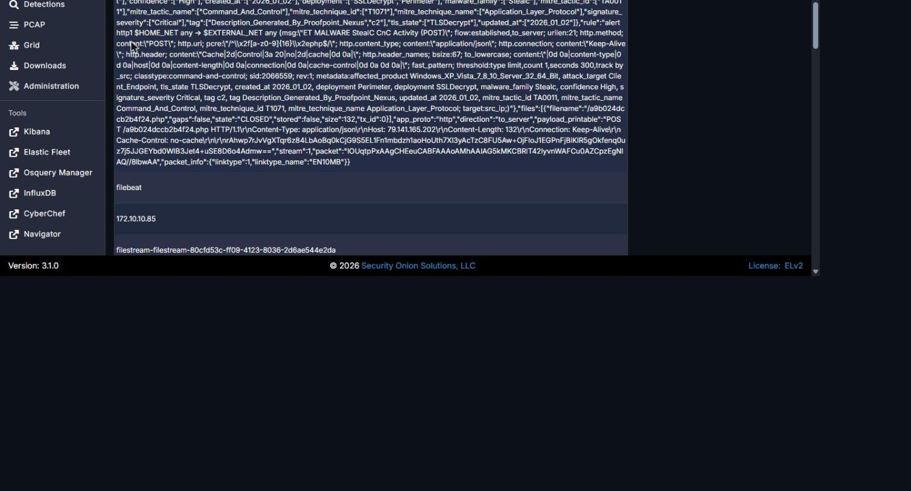
Figure 2 - Expanded Suricata alert raw payload showing 'POST /a9b024dccb2b4f24.php HTTP/1.1', Host: 79.141.165.202, and rule metadata malware_family: Stealc.

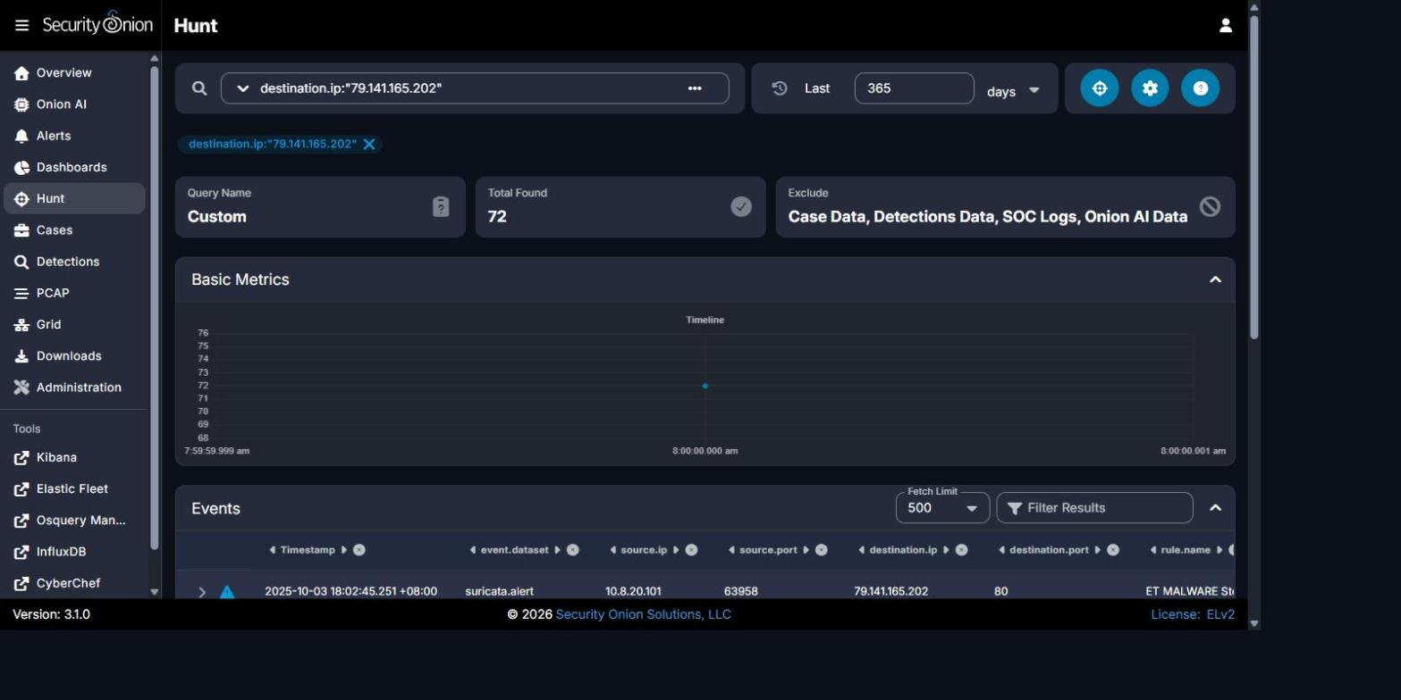
Figure 3 - Security Onion Hunt pivot on destination.ip:"79.141.165.202" returning 72 correlated events (suricata.alert / zeek.http / zeek.file).

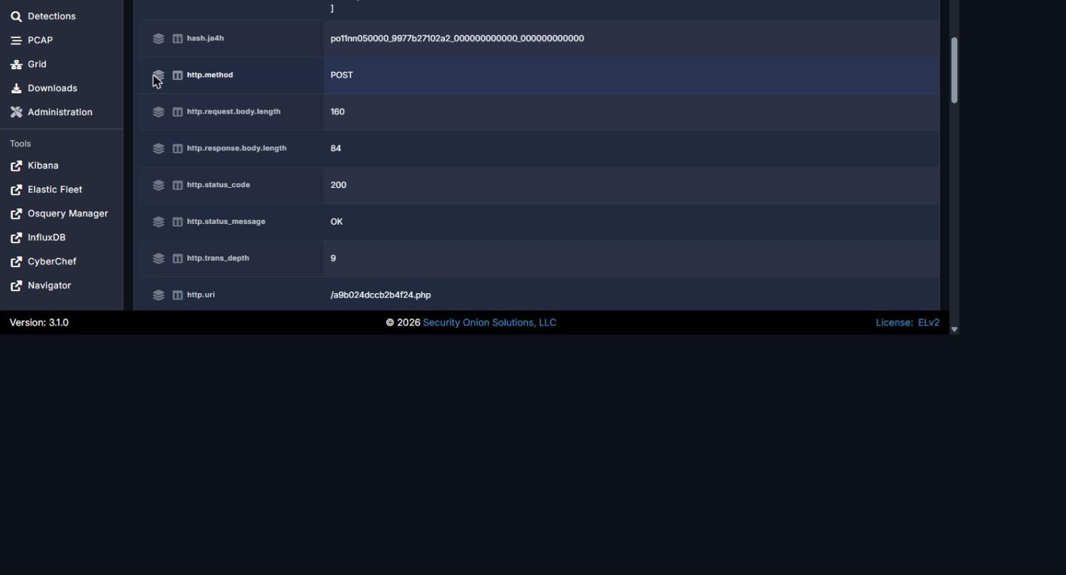
Figure 4 - Zeek http.log expanded record showing http.method: POST and http.uri: /a9b024dccb2b4f24.php.

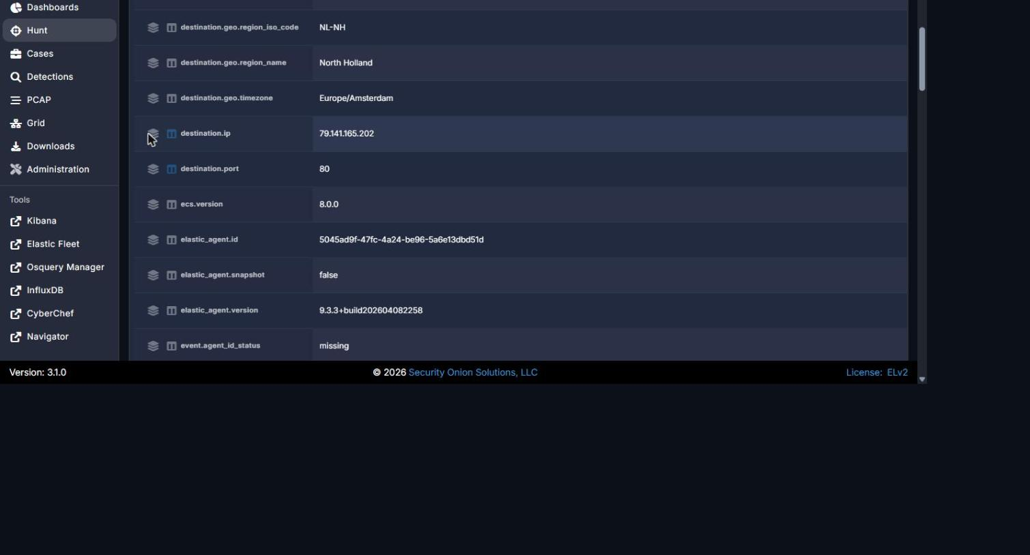
Figure 5 - Zeek http.log expanded record showing destination.ip: 79.141.165.202, destination.port: 80, GeoIP Amsterdam, Netherlands (HZ Hosting Ltd, AS59711).

REPORT QUALITY REQUIREMENTS
5% - 50 Points
- Clear and logical organization
- Correct technical terminology
- Accurate use of timestamps
- Readable screenshots
- Properly labeled tables and figures
- Consistent evidence references
- Clear distinction between confirmed facts and analyst inference
- Professional presentation and readability

SUBMISSION INSTRUCTIONS
1. Submit one report for each phase designated as Report-Required.
2. Submit the final report in PDF format unless otherwise directed.
3. Clearly indicate the team name, phase number, and phase title.
4. Use UTC for timestamps.
5. Major findings must be supported by evidence.
6. Screenshots must be numbered and captioned.
7. Do not include executable malware samples in the report.
8. State 'Not Determined' when a finding cannot be confirmed.
9. Ensure all screenshots, tables, and text are readable.
10. Reports must be submitted before the deadline announced by exercise control.
Evidence Rule: A correct finding without supporting Security Onion, Kibana, Elasticsearch, Zeek, Suricata, or other authorized evidence may receive no more than 50% of the points assigned to that finding. Incorrect or fabricated evidence receives zero points for the affected finding.

